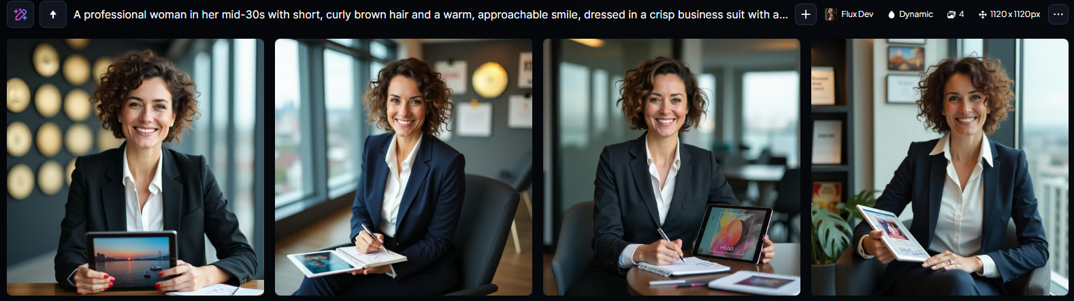

"A professional woman in her mid-30s with short, curly brown hair and a warm, approachable smile, dressed in a crisp business suit with a fitted white blouse and a tailored blazer, sits confidently in a modern office setting, surrounded by industry awards and promotional materials, with a cityscape visible through the floor-to-ceiling windows behind her, holding a tablet with a colorful advertisement on the screen, and a notebook with scribbled notes and a pen in her hand, exuding an air of authority and creativity, with a subtle hint of playfulness in her bright brown eyes and a few strands of hair framing her heart-shaped face with a smooth, olive-toned complexion.”

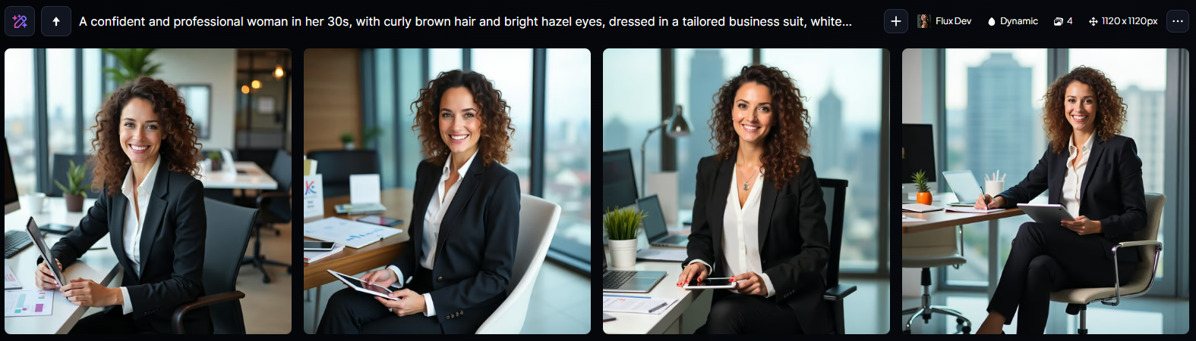

“A confident and professional woman in her 30s, with curly brown hair and bright hazel eyes, dressed in a tailored business suit, white blouse, and high heels, sitting at a modern, sleek desk with a cityscape view behind her, surrounded by marketing materials, laptops, and promotional items, holding a tablet and smiling directly at the camera, with a warm and approachable expression, conveying authority and expertise in her role as an Advertising and Promotions Manager, with a subtle hint of creativity and playfulness in her demeanor.”

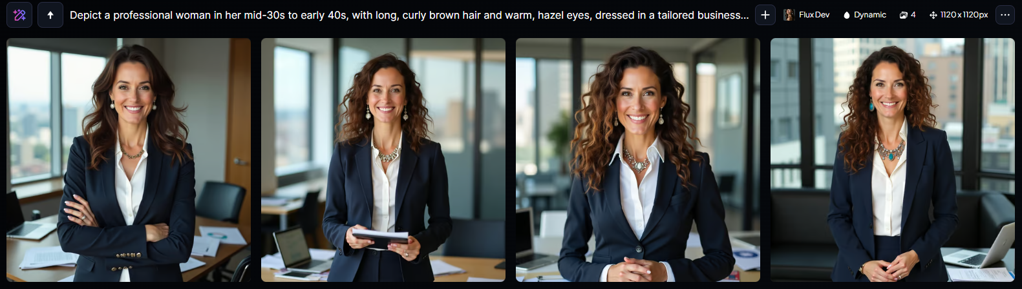

“Depict a professional woman in her mid-30s to early 40s, with long, curly brown hair and warm, hazel eyes, dressed in a tailored business suit, likely navy blue or black, with a crisp white blouse and a statement piece of jewelry, such as a bold necklace or earrings, standing confidently in a modern office setting with a cityscape or metropolitan background, surrounded by props like laptops, papers, and marketing materials, with a friendly yet assertive expression, conveying a sense of authority and competence, as if she is in the midst of a meeting or pitching an idea, with a subtle smile playing on her lips, and a few strategically placed papers or a tablet in her hands.”